Blockchain Based ZTNA System

In existing application all business or organizations digital data were managed in a single centralized server or cloud servers. Data store in such servers always face security issues and risk of data leak or tamper and to verify this data integrity 3rd party verification were involved. This 3rd parties cannot be trusted as they may can temper data by altering server database. Due to this reason many unprofessional and experienced employees will alter their activities recorded in access logs.

To combat above data security issues we are employing Blockchain Based ZTNA system as Blockchain has inbuilt support for Decentralized (data store or replicated at multiple nodes in a network) and tamper proof storage and required no third party API or tools for verifications as it has its own hash code based verification.

Blockchain store each record as block/transaction and associate each block with unique hash code and this hashcode will get verify for each subsequent block storage. If data unchanged then same hashcode will generate and verification get successful. This verification process make Blockchain secured and tamper proof and whose activities log can be tamper in any manner.

Blockchain can save and retrieve data using Smart Contracts which can be designed using SOLIDITY programming and this contract contains role or attributed based access which allow only authenticated or permitted user to access the data. To manage log activities and organization files data we have designed following SMART Contract.

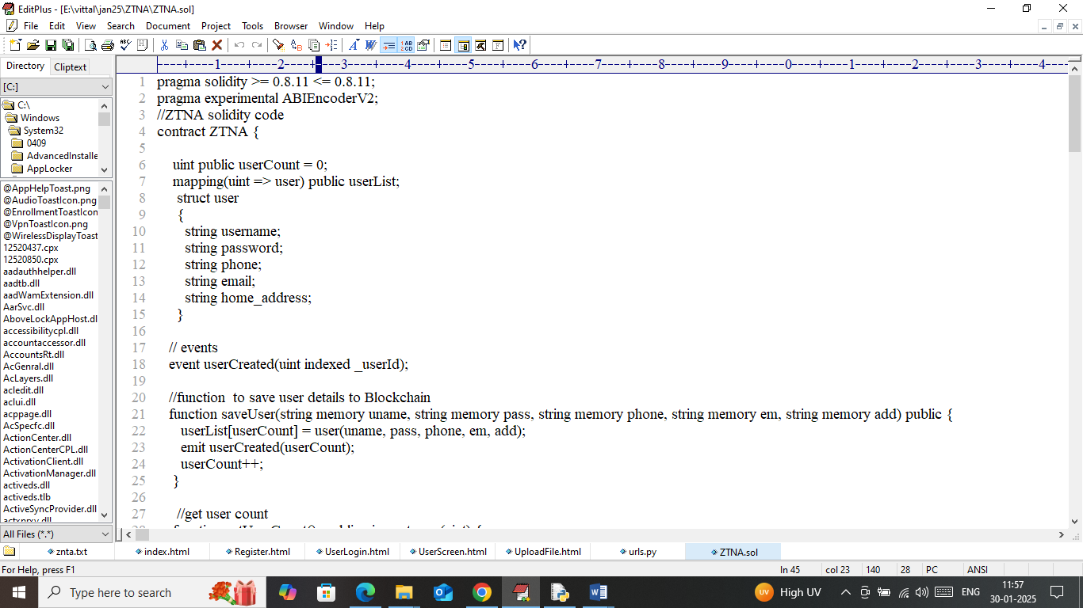

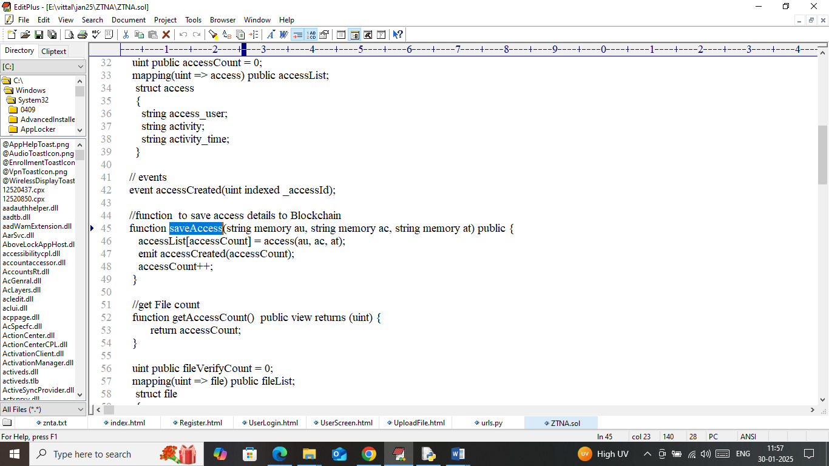

In above contract we have defined functions to manage organization user’s data as well as to record their activities. Now we need to deploy above contract to Blockchain Ethereum using below steps

1. First go inside ‘hello-eth/node-modules/bin’ folder and then look and double click on ‘runBlockchain.bat’ file to get below page
2. 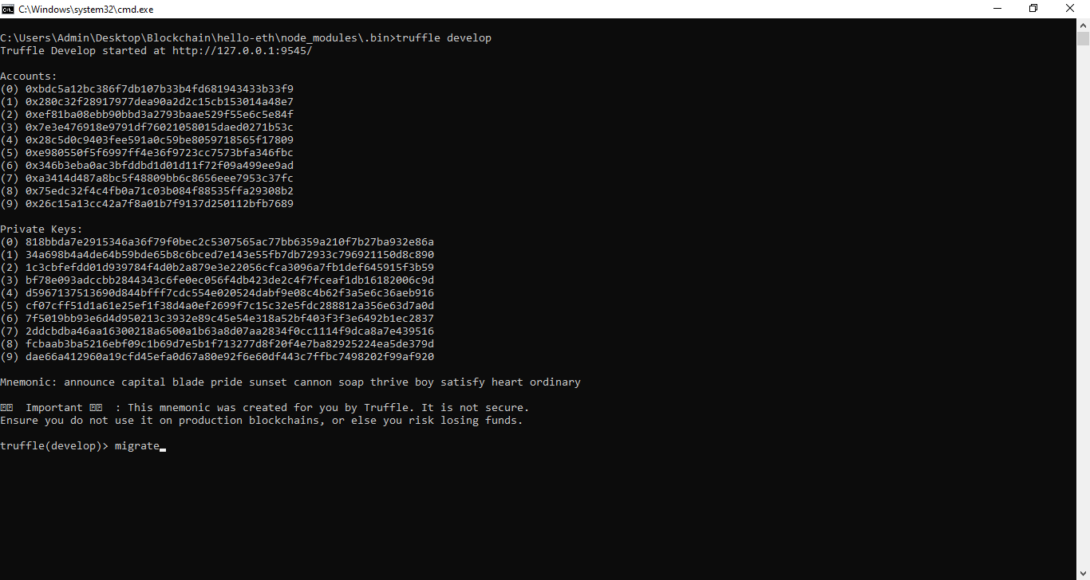
3. In above screen Blockchain Ethereum started with default key and accounts and now type command as ‘migrate’ and then press enter key to get below page
4. 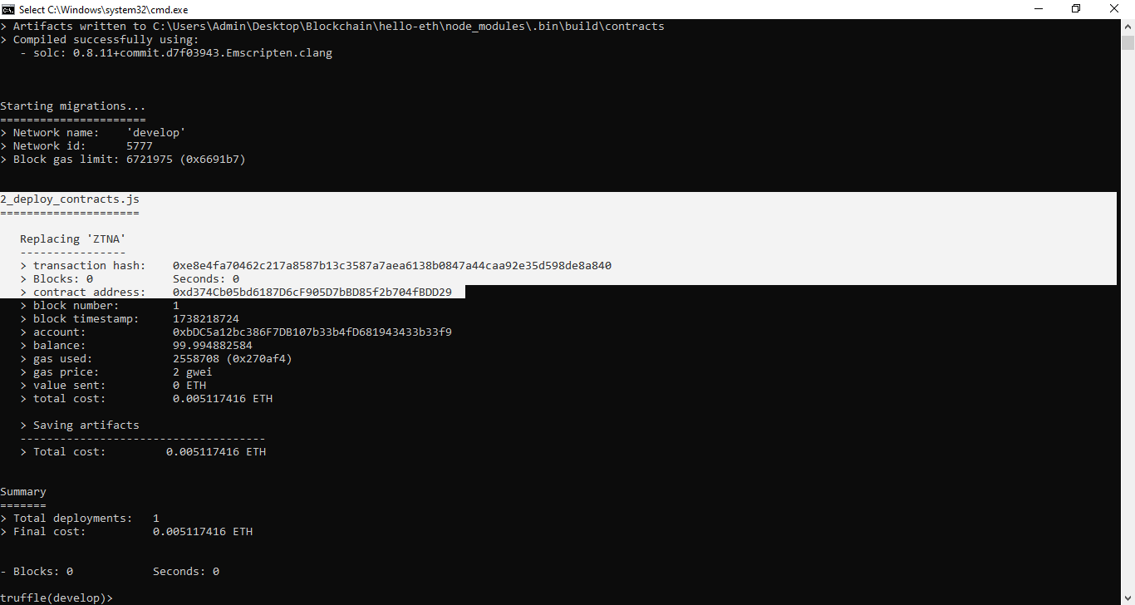
5. In above screen in white text can see ‘ZTNA’ contract deployed and running successfully and let run till you execute project. In above screen we got contact address and this address we can specify in python code to call above contract to save all access details to Blockchain. In below screen showing python code calling above contract using address
6. 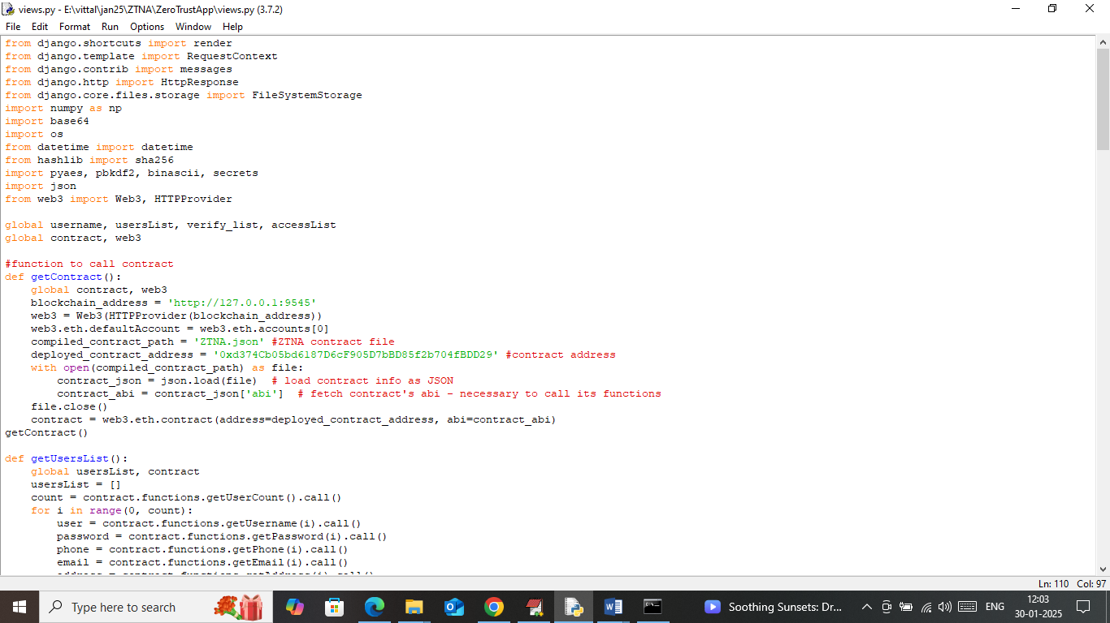
7. In above screen see red colour comments to know about contract calling using address

**Implementation Modules: to implement this project we have designed following modules**

1. New User Sign up: using this module user can sign up with the Blockchain
2. User Login: user can login to system
3. Save Data To Blockchain: using this module user can upload any file which will get encrypted using AES algorithm and then choose access role as Public or Private and only Public files can be access by all the users. Blockchain allow only public files to be downloaded by other users and owners can download both public and private files. Whoever user accessing any file or doing any activities will get recorded in Blockchain
4. Access Data: Allow user to view and download only role based access files or data
5. View Access Activities: Allow user to view activities perform by him and other users.

SCREEN SHOTS

To run project double click on ‘run.bat’ file to start python cloud server and get below page

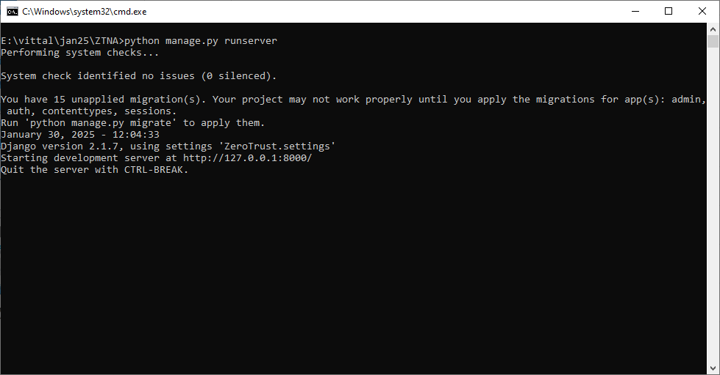

In above screen python server started and now open browser and enter URL as <http://127.0.0.1:8000/index.html> and press enter key to get below page

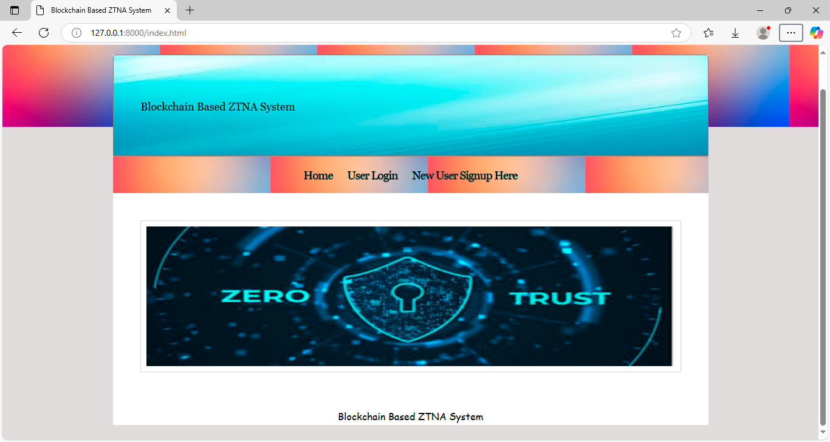

In above screen click on ‘New User Signup’ link to get below page

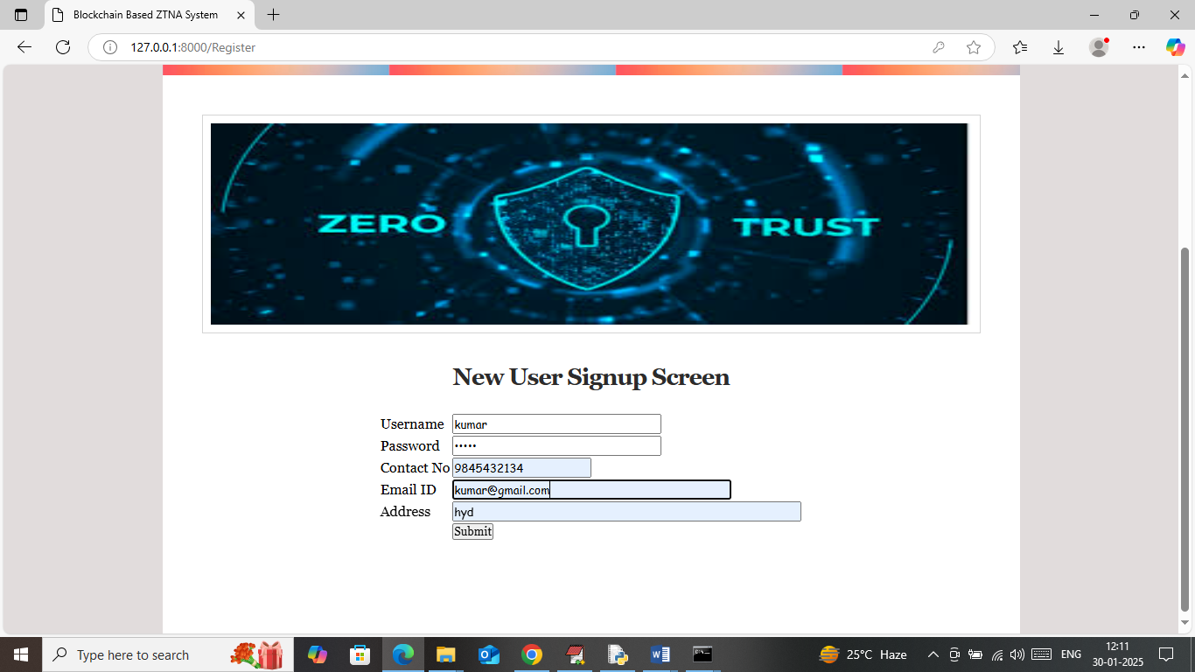

In above screen user is entering sign up details and then press button to get below page

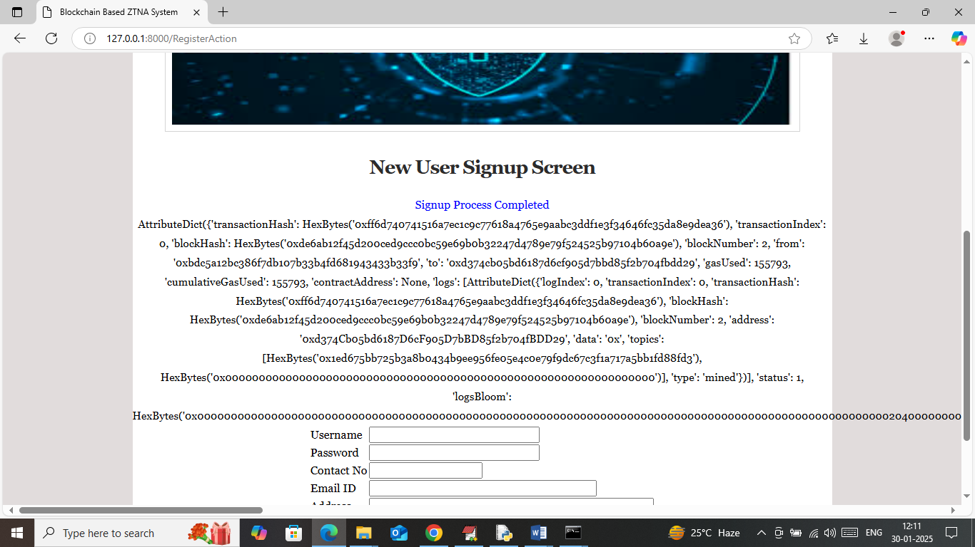

In above screen user sign up details saved in Blockchain and then I am displaying all log details obtained from Blockchain which contains details like Block no, transaction no, hash code and many other details. By showing above details you can say to your guide that details are saving in Blockchain. Now click on ‘User Login’ link to get below page

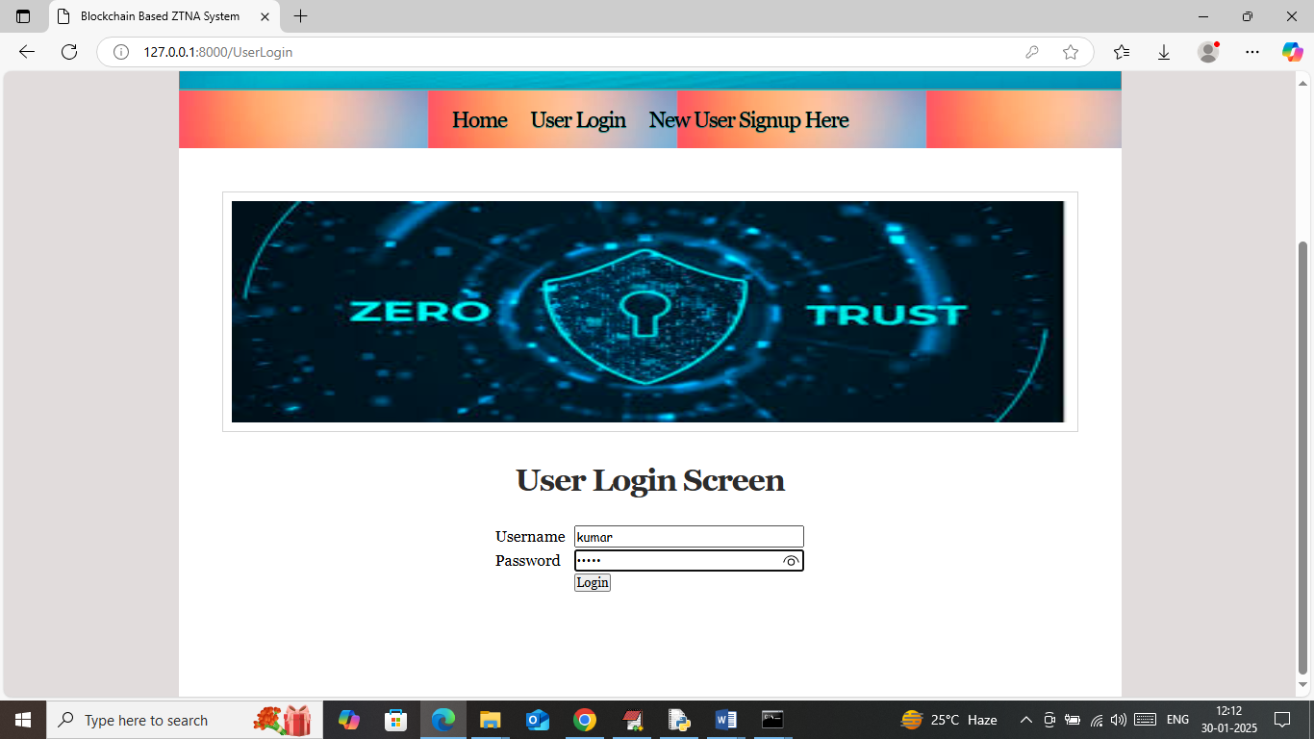

In above screen user is login and after login will get below page

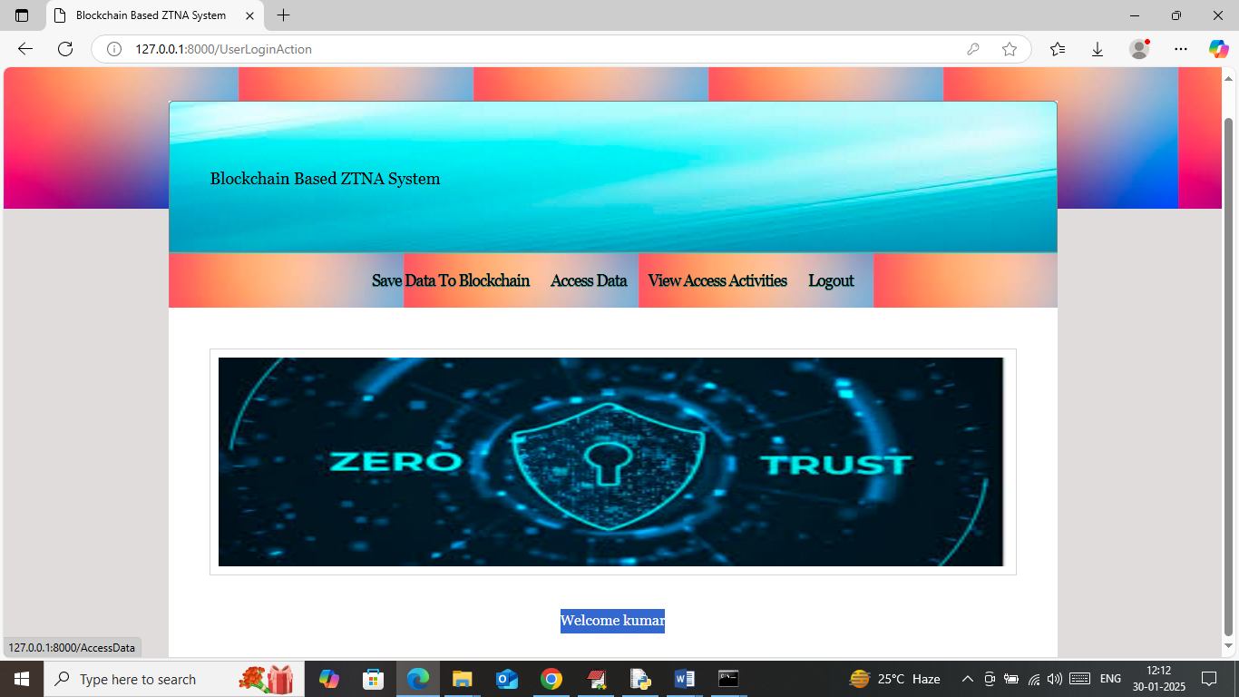

In above screen user can click on ‘Save Data To Blockchain’ link to upload file to Blockchain and then will get below page

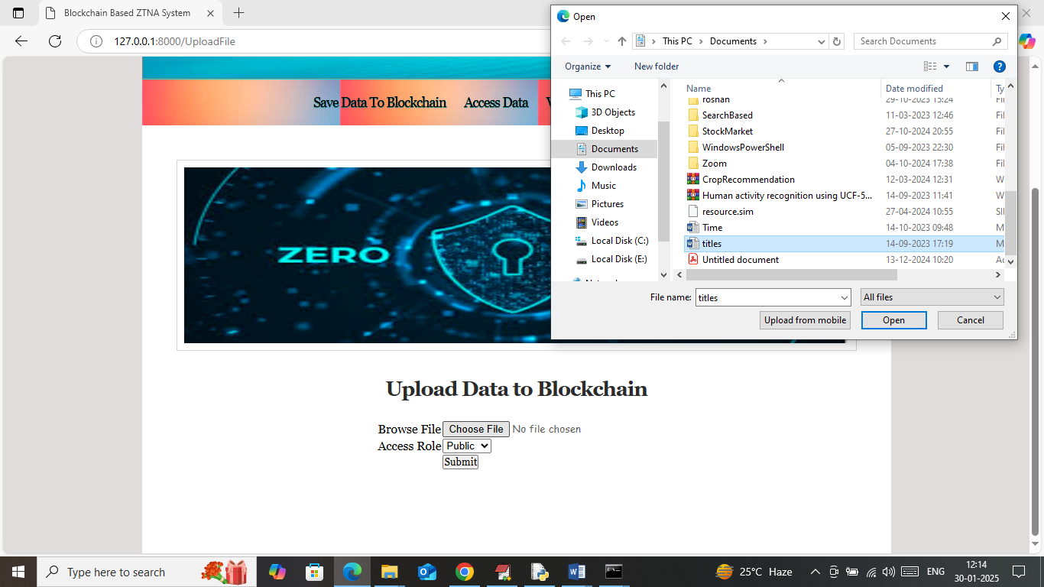

In above screen selecting and uploading some file and then selecting access role as ‘Public’ and then press buttons to get below page

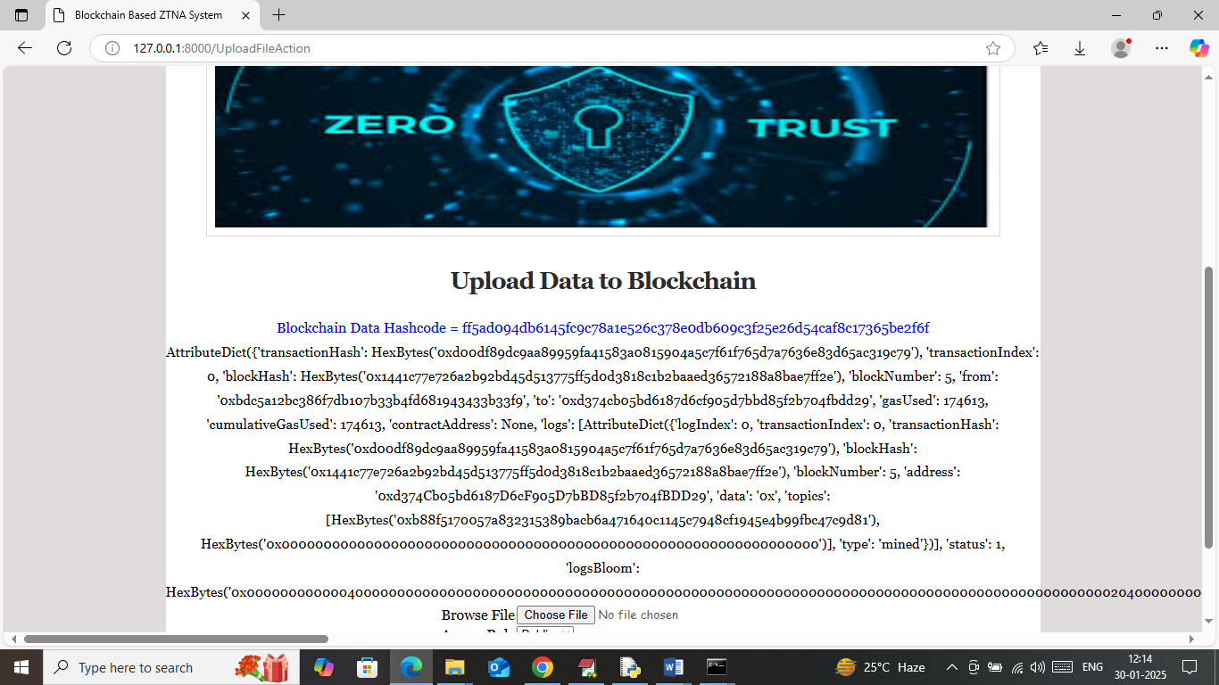

In above screen file details saved in Blockchain along with hash code and can see all log obtained from Blockchain and similarly you can upload as many files you want and now click on ‘Access Data’ link to get below page

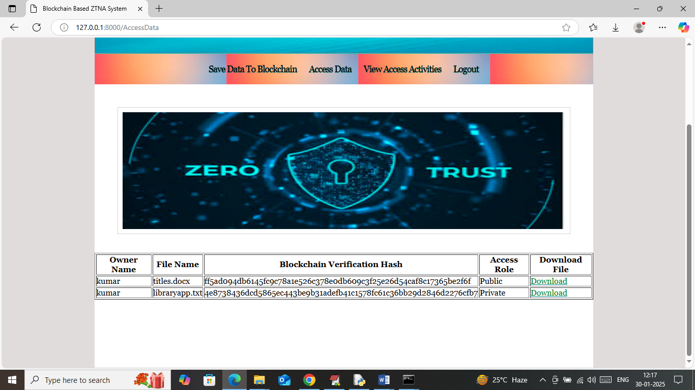

In above screen data owner can view and download all public or private files and other user can access only private files and in above screen can see owner details along with file hash and can click on ‘Download’ link to download file and get below page

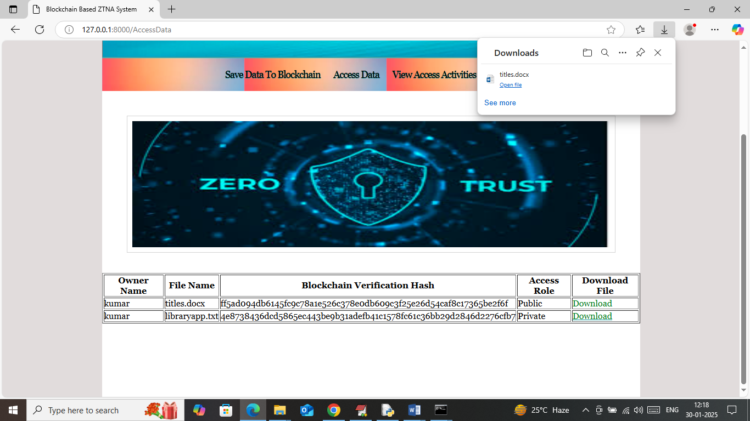

In above screen in browser status bar can see file will be downloaded in decrypted format and now click on View Access Activities’ link to get below page

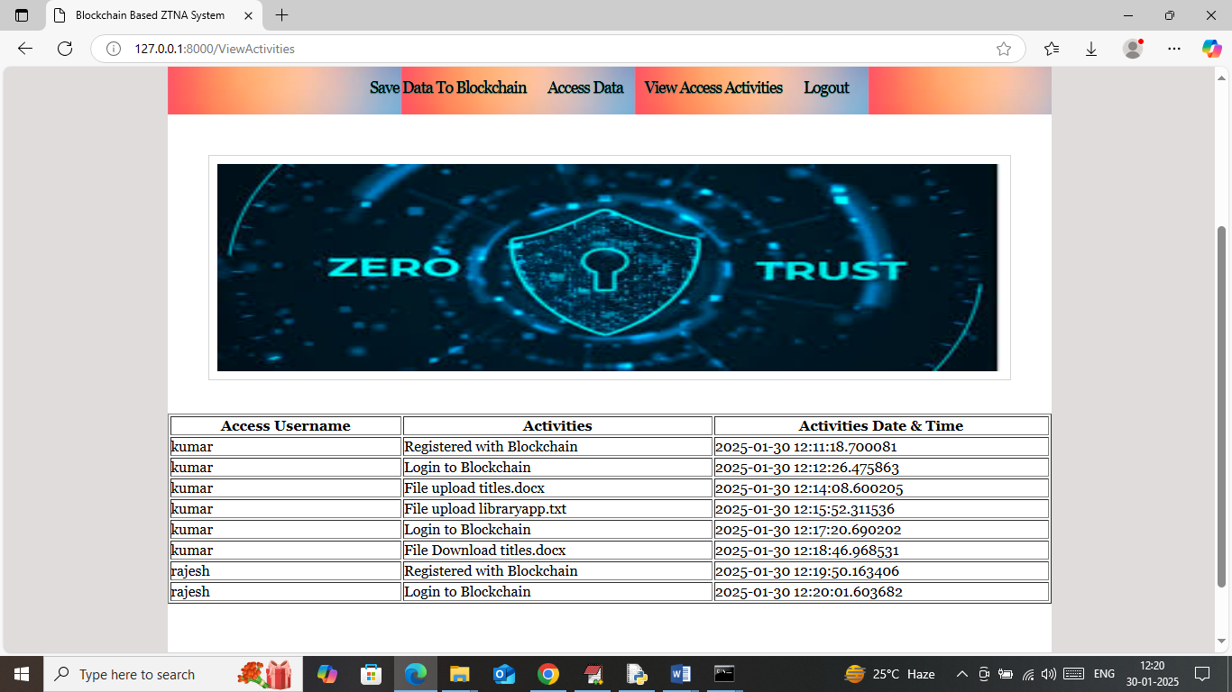

In above screen can see all user activities log data along with activity name, date and time. Above log will be saved in Blockchain with tamper proof storage. Now click on ‘Access Data’ with other user login

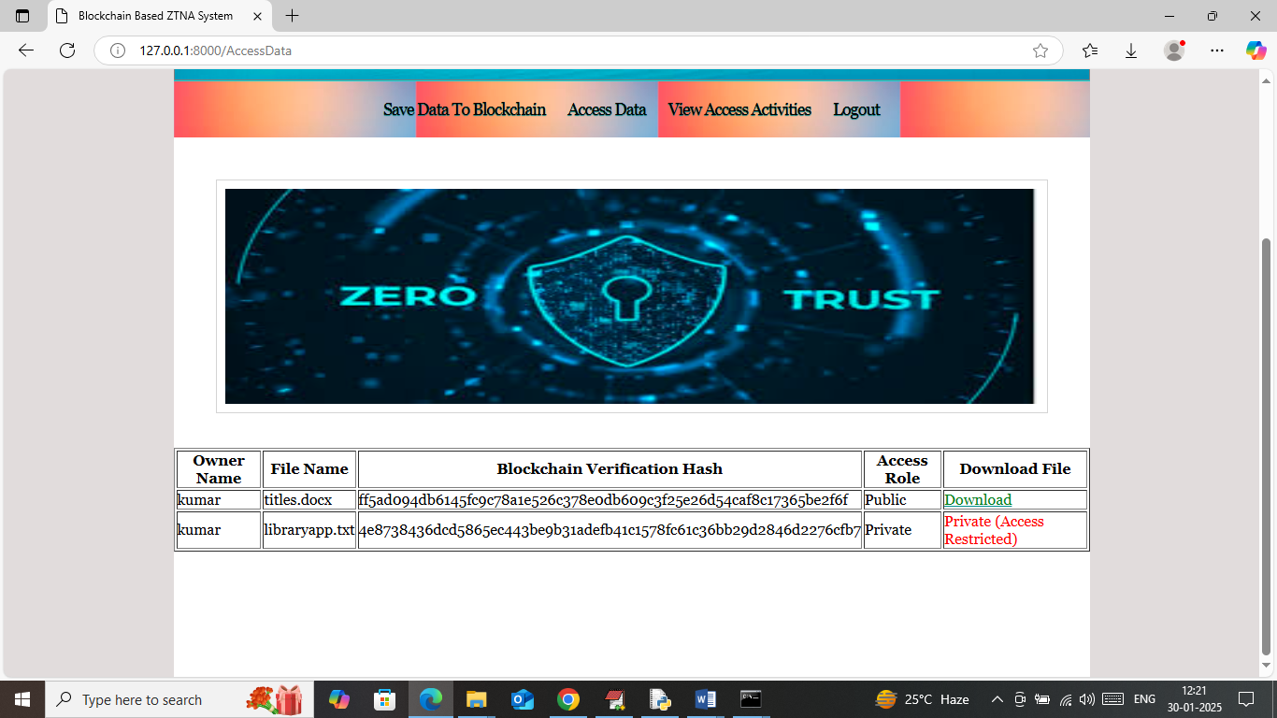

In above screen accessing user is not owner so he will not download private data with access restricted but can access public role files.

So by using above application you can manage all organization or business data with tamper proof storage.